**School of Science and Technology**

**Virtual Reality**

**ITEC30141**

**VR Reaction Game for Neuropsychological Assessment**

**By**

**Michal Nickel**

**N1075587**

**Tutor: James Lewis**

**Introduction**

This document presents a VR-based reaction game designed as a neuropsychological assessment tool. Traditional reaction time tests are commonly used in cognitive research and medical evaluations *(Smith et al., 2020)*. This project explores how virtual reality (VR) can enhance cognitive testing by providing an immersive, interactive environment.

The project was completed within a short timeframe, without prior VR development experience, focusing on fundamental reaction time tracking while considering future improvements in adaptability and advanced cognitive training. The game enables users to assess and train their reaction speed in a VR setting, with potential applications in:

* Cognitive research – Measuring attention, reflexes, and reaction speed in a more ecologically valid setting *(Posner & Petersen, 1990).*
* Athletes & gamers – Enhancing hand-eye coordination and response time, which is crucial for performance *(Kida et al., 2005).*
* Neuropsychological assessments – Exploring VR as an alternative to traditional reaction time tests, which may improve engagement and test accuracy *(Parsons et al., 2017)*.

By integrating VR, this game aims to improve neuropsychological assessments by making them more immersive and ecologically valid while maintaining the core principles of reaction time testing.

**Purpose of the Game as a Neuropsychological Assessment**

Reaction time assessments are widely used in sports science, cognitive psychology and medical research *(Kosinski, 2008).* Traditionally, these tests involve pressing a button when a stimulus appears. However, such tests can be:

* Repetitive and disengaging, potentially reducing participant motivation *(Rand et al., 2019).*
* Limited in real-world applicability, as they do not simulate natural motor responses.
* Lacking full-body movement tracking, which could be important in assessing motor function impairments.

This VR-based reaction game enhances traditional assessments by:

* Integrating full-body motion tracking via Oculus controllers, which allows for a more accurate assessment of motor coordination *(Faria et al., 2018).*
* Presenting stimuli in a 3D space rather than on a 2D screen, improving spatial awareness evaluation *(Lowe & Rabbitt, 1998).*
* Providing a more immersive and engaging test environment, which has been shown to improve participant performance in cognitive tasks *(Bohil et al., 2011)*.

By maintaining the core principles of reaction time testing while leveraging VR, this game enhances neuropsychological assessments by increasing engagement, improving ecological validity and potentially yielding more reliable data.

**Key Features and Mechanics**

1. **Core Gameplay Mechanics**
   1. Randomised Light Target Appearance
      1. A light will appear at random locations in front of the player.
      2. The player must quickly react and tap the light to register a successful response.
   2. Reaction Time Management
      1. The time taken from light appearance to tap will be recorded for assessment.
      2. This measures cognitive processing speed and motor response, key indicators in neuropsychological evaluations *(Van Zomeren & Brouwer, 1994).*
   3. Hit Accuracy Tracking
      1. If a player misses a light or reacts too slowly, it will be counted as a miss, helping assess decision-making under pressure *(Baumeister et al., 2008).*
      2. Score will be displayed at the end of the session based on reaction time and accuracy.
2. VR Features
   1. Full Hand and Controller Tracking
      1. Oculus controllers track hand speed and accuracy, offering precise interaction with stimuli, which is crucial in assessing motor deficits *(Levac et al., 2019).*
   2. Reaction Training
      1. Targets appear in different locations, requiring full-body awareness, mirroring real-world sports or rehabilitation drills *(Craig, 2013).*
   3. Immersive 3D Boxing Environment
      1. The game takes place in a virtual boxing gym or ring, enhancing realism and engagement. This setting has been linked to improved performance in motor and cognitive tasks *(Bohil et al., 2011).*
   4. Haptic & Audio Feedback
      1. Controllers vibrate when a correct tap is registered, reinforcing learning through sensory feedback *(Howard et al., 2017).*
      2. Audio cues provide real-time feedback on performance, improving user engagement *(Murray, 2018).*

**Neuropsychological Elements in the Game**

This VR game targets multiple cognitive functions that are essential in reaction-based neuropsychological assessments:

|  |  |
| --- | --- |
| **Cognitive Function** | **How It’s Tested in the Game** |
| Reaction Time | Player must quickly respond to randomly appearing lights. |
| Hand-Eye Coordination | Precise hand movements are required to interact with stimuli. |
| Attention & Focus | Players must stay alert and ignore distractions. |
| Decision-Making Under Pressure | In higher difficulty modes, players must choose the correct response. |
| Motor Control & Precision | Movements are tracked in VR, ensuring controlled and accurate responses. |

VR’s ability to measure and train these cognitive functions makes it a promising tool for neuropsychological research and clinical applications, such as concussion monitoring and attention assessments *(Parsons et al., 2017).*

**Benefits of the Game for Players**

**For Athletes & Gamers**

* Enhances reflexes and reaction speed, crucial for competitive performance *(Kida et al., 2005).*
* Improves cognitive-motor coordination, aiding in fast decision-making *(Craig, 2013).*
* Simulates real-world response situations using VR immersion *(Bohil et al., 2011).*

**For Neuropsychological Research & Rehabilitation**

* Monitors cognitive function in aging populations or individuals recovering from brain injuries *(Rand et al., 2019).*
* Provides an alternative to traditional reaction time assessments, which may be less engaging *(Faria et al., 2018).*
* Potential applications in ADHD research for attention and impulse control analysis *(Seidman, 2006).*

**For General Users**

* Engaging brain-training experience that encourages cognitive engagement.
* Supports focus, awareness, and quick decision-making in a gamified setting.

**Implementation & Key Features**

Technology Stack

|  |  |
| --- | --- |
| **Component** | **Technology Used** |
| Game Engine | Unreal Engine 5.4.4 |
| VR Integration | Oculus SDK (OpenXR) |
| Motion Tracking | Oculus controllers for interaction |
| Physics System | Basic object collision detecting |
| Environment | Simple VR space for distraction-free testing |

**Ethical & Safety Considerations (PSEL Issues)**

Privacy & Data Protection

* No biometric or personal data is stored. Ensuring user privacy compliance (GDPR guidelines).
* The game only tracks reaction times locally, minimising data security risks.

Safety Considerations

* The game minimizes motion sickness risks by keeping the player in a static position *(Chang et al., 2020)*.
* Short play sessions reduce fatigue, making it suitable for medical assessments.

Ethical Considerations

* This game does not replace formal clinical assessments but explores VR’s potential in neuropsychological testing (Parsons et al., 2017).

**Screenshots & Explanation of Development Process**

This section includes:

* Screenshots of Unreal Engine Blueprint nodes for reaction tracking
* Images of the VR environment, light stimuli and user interaction
* Annotations explaining key implementation steps

**3D VR Environment**

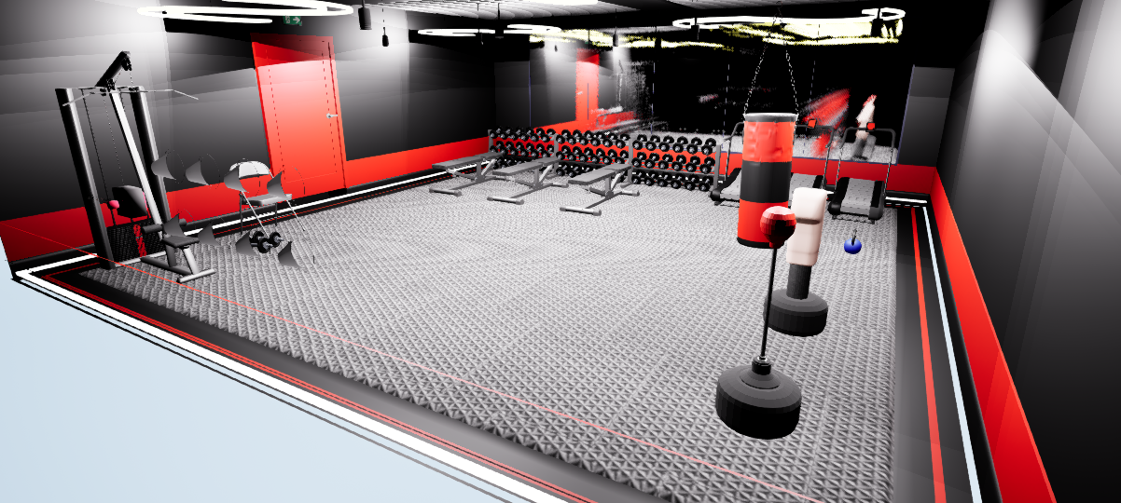

The VR environment was created in Unreal Engine 5.4.4, using custom assets to simulate a closed gym setting, a common location for reaction-based training. The environment includes machines, boxing equipment, dynamic lighting, a reflective mirror and interactive dumbbells/kettlebells. Materials and collisions were configured to enhance realism. Some assets required manual assembly and resizing in Unreal Engine Blueprints due to import limitations.

**Reaction Game Mechanics**

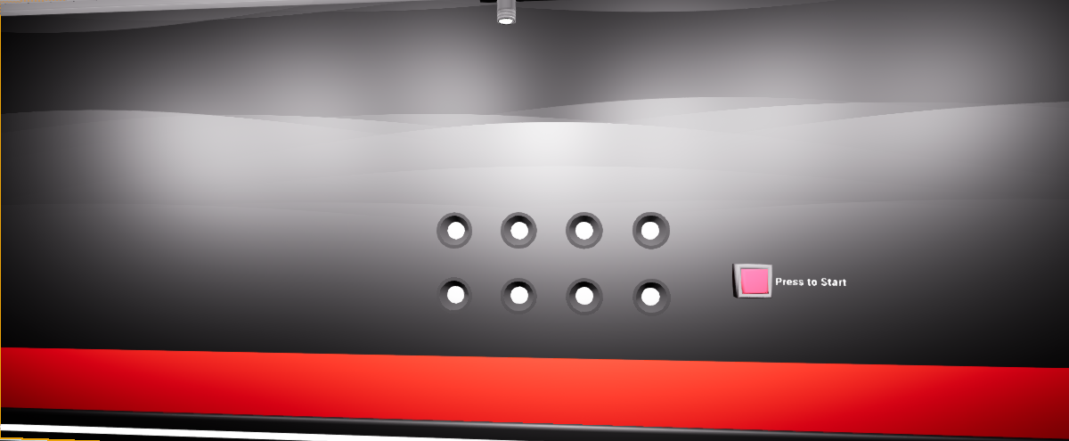

Upon spawning, the reaction game area is located behind the player. To start, the player presses a button using their motion controller, triggering an animation and sound cue. Lights then begin to appear in a random order and the player must touch them as quickly as possible. Each correct touch turns off the light, plays a sound effect, and increments the score. The game runs for 30 seconds, after which a congratulations message and score are displayed for three seconds, accompanied by firework sound effects. The game can be restarted by pressing the button again after the timer resets.

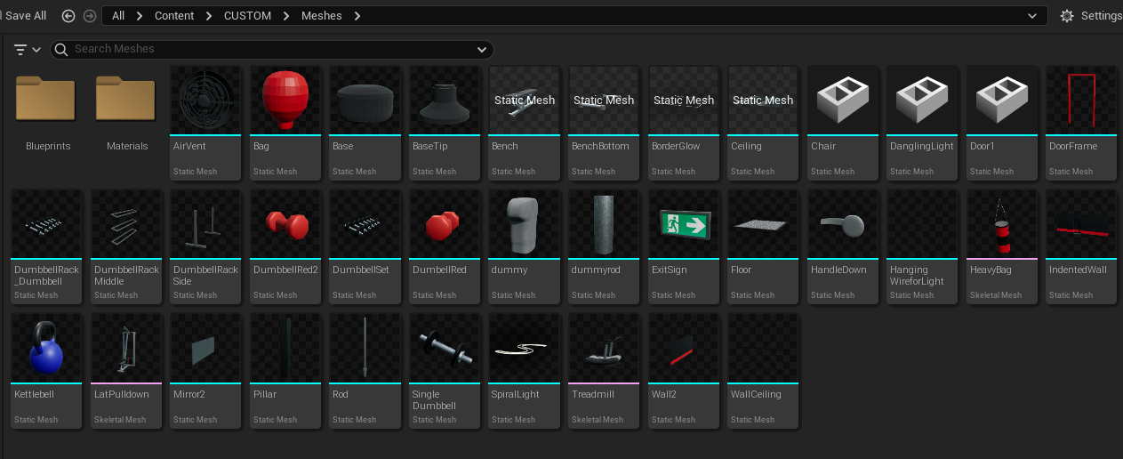

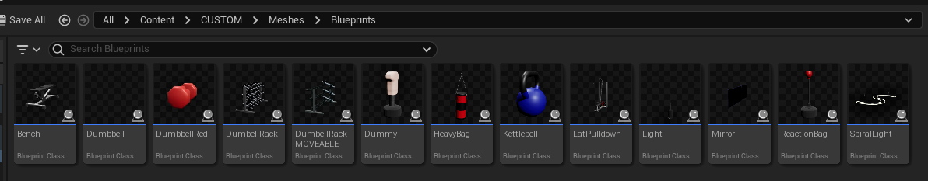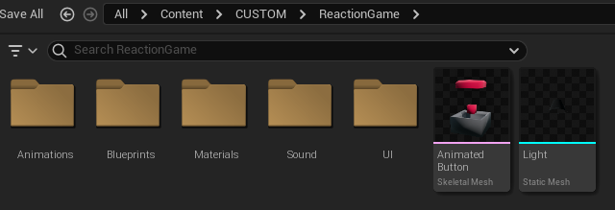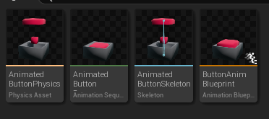

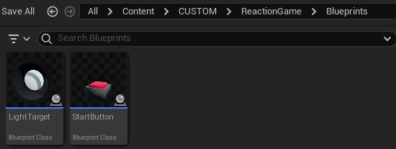

The imported assets folder contains all optimised assets used to develop the gym’s visuals and interactivity. These assets contribute to a more immersive and aesthetically polished environment.

**Interactive / Grabbable Items**

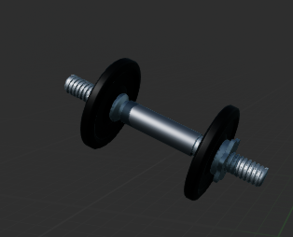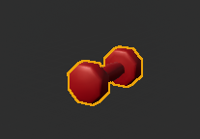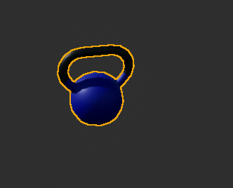

Future updates could introduce additional interactive elements, such as allowing players to use gym machines and manipulate more objects with VR motion controls. The primary focus of this iteration was establishing core functionality and ensuring basic interactivity within the VR environment.

**UI**

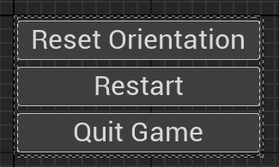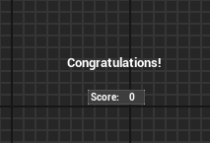

The game includes a pause menu that allows users to:

* Reset their orientation
* Restart the game
* Exit the game

Users access the menu by pressing the left Oculus controller’s menu button. Additionally, a score screen briefly appears at the end of each session, displaying the player’s final score and a congratulations message.

**VR Pawn (Game Audio & Interaction)**

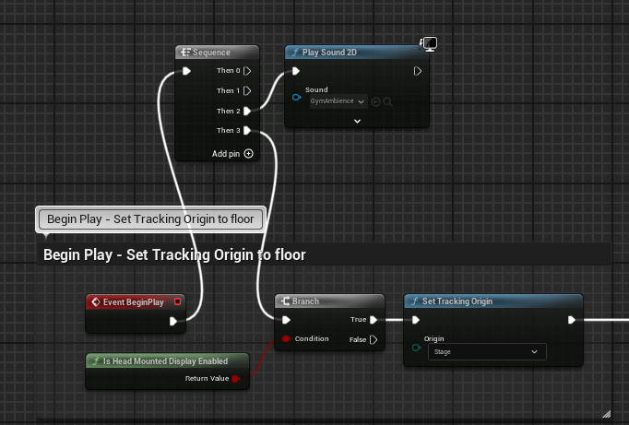

Ambient Background Noise - A sequence node was used in the VR Pawn’s event graph to ensure gym background sounds play alongside other game functions.

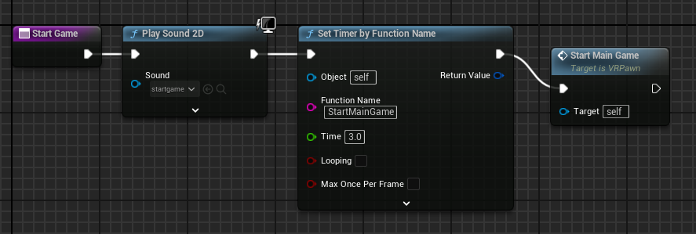

Start Game Function -When the start button is pressed, a 3-second timer begins, playing a sound cue before launching the main game loop.

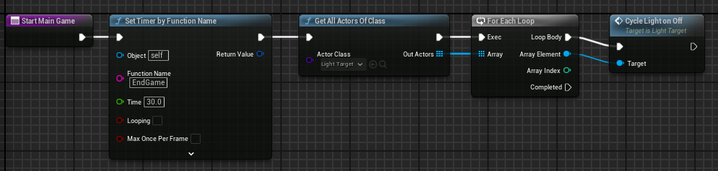

Main Game Function - The game runs for 30 seconds, continuously activating the light cycle function inside the Light Target Blueprint.



End Game Function - After 30 seconds, the game stops all light cycles, displays the score widget, and plays a fireworks sound effect.

**Start Button Blueprint**

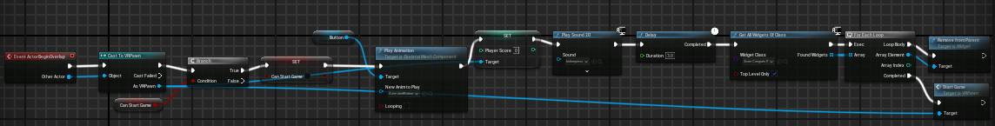

To start the game, the player must overlap with the collision sphere, triggering:

* Button animation & sound
* Score reset
* Widget removal
* Start Game Function execution

**Light Target Blueprint (Reaction Logic)**

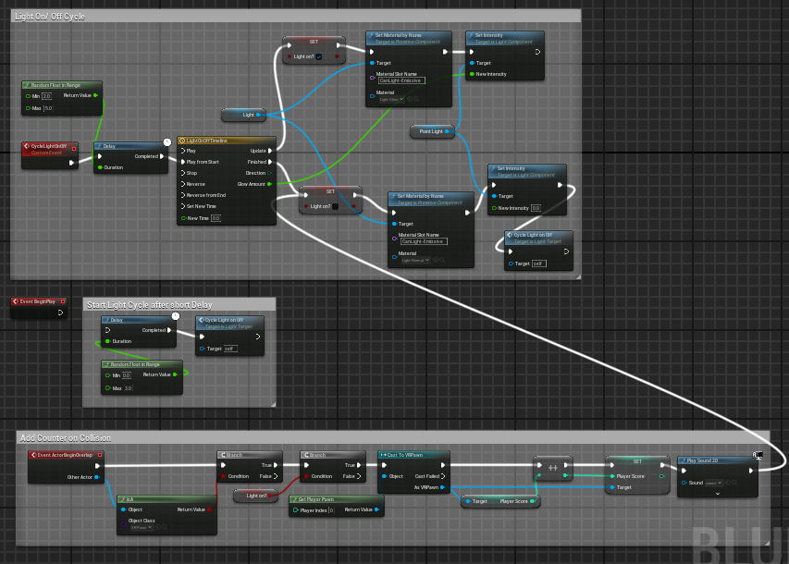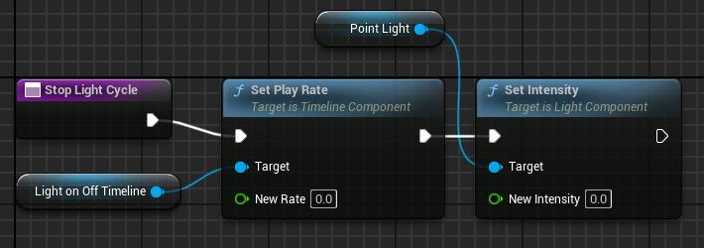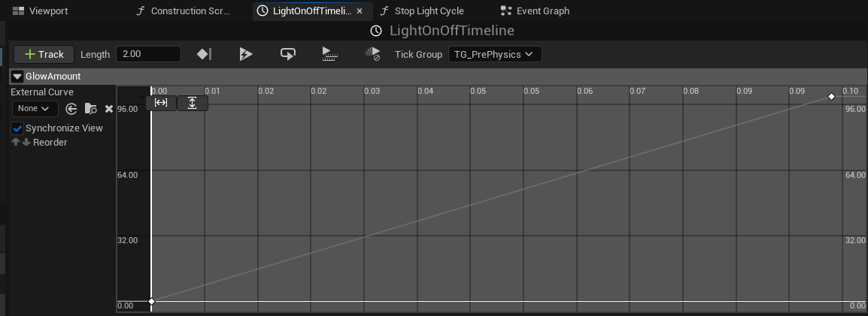

The Light Target Blueprint controls the light appearance cycle and reaction tracking:

Randomised Light Activation: Lights turn on and off in a randomised sequence.

Light Animation: A timeline adjusts light intensity, briefly turning it glowing red before requiring a response.

Collision Detection & Score System:

* If the player touches a lit light with their motion controller, the system checks if it's active.
* If correct, the score increases, the light turns off, and a sound cue plays.
* The light then re-enters the random activation loop until the 30-second game duration ends.

**Development Progression**

Throughout development, rigorous iterative testing was conducted following the implementation of each major component. In the early iterations, performance optimisation posed a significant challenge, leading to lengthy load times, frame rate drops, and degraded visuals. Various settings were adjusted to improve stability, though performance issues remained a persistent concern, particularly when optimising for deployment on standalone VR hardware.

The game was developed and tested primarily on an Oculus Quest 2, which introduced hardware limitations affecting rendering quality and performance. Unreal Engine’s VR Preview provided a higher-quality visual representation, but once deployed to the headset, performance often deteriorated due to hardware constraints and rendering limitations. The absence of comprehensive guidance on optimising Unreal Engine projects for multiple Oculus platforms further complicated the process.

Despite these challenges, each iteration of the game was packaged and deployed for testing, allowing for a step-by-step evaluation of its progression. The final iteration represents the most complete and optimised version of the game, though additional improvements in frame rate stability, graphical fidelity and asset optimisation remain areas for future refinement.

**Results and Findings**

User testing is a critical step in evaluating the effectiveness of this VR reaction game as a neuropsychological assessment tool. Traditional reaction time tests rely on button presses, which lack ecological validity and fail to engage users fully *(Kosinski, 2008)*. VR-based assessments have been shown to improve test accuracy, increase engagement, and offer a more immersive and interactive approach to cognitive testing *(Parsons et al., 2017).*

The testing process aims to assess:

1. Reaction Time Variations Among Different Users
   * Measuring individual differences in cognitive processing speed and motor response can provide insights into attention, reflexes and neurological health *(Van Zomeren & Brouwer, 1994).*
   * This is particularly useful for detecting cognitive impairments in conditions such as traumatic brain injury (TBI) and neurodegenerative diseases *(Rand et al., 2019).*
   * VR-based reaction time assessments have been linked to more accurate detection of cognitive decline compared to traditional methods *(Bohil et al., 2011).*
2. Engagement and Usability Feedback
   * User immersion in neuropsychological testing is crucial for ensuring reliable data collection. Studies show that increased engagement correlates with improved cognitive test performance *(Howard et al., 2017).*
   * Traditional reaction time tests often cause fatigue and loss of interest, leading to lower data reliability *(Lowe & Rabbitt, 1998).* The VR reaction game addresses this issue by maintaining high user engagement through interactive and immersive mechanics.
3. Accuracy and Consistency of Recorded Reaction Times
   * Neuropsychological tests must be reliable to be clinically useful. VR technology allows for precise motion tracking and reaction time recording, eliminating inconsistencies found in standard tests *(Levac et al., 2019).*
   * In our game, motion-tracked responses provide a higher degree of accuracy than keyboard/mouse-based reaction tests, making it a more valid neuropsychological assessment tool *(Faria et al., 2018).*

**Future Enhancements**

While initial testing demonstrates the effectiveness of VR in reaction time assessments, several enhancements could further optimise its use in neuropsychology, rehabilitation and cognitive training:

1. AI-Driven Adaptive Learning
   1. Implementing AI-driven difficulty adjustment based on the player’s reaction speed and accuracy could make the game more personalised and clinically relevant.
   2. Adaptive testing has been shown to increase cognitive test sensitivity, making it easier to identify minor deficits in processing speed *(Parsons et al., 2017).*
   3. This feature could be especially useful for tracking cognitive decline in aging populations or concussion recovery *(Rand et al., 2019).*
2. Expanded Cognitive Tests
   1. Memory-based pattern recognition tasks could be integrated to assess cognitive flexibility and working memory, which are often impaired in conditions such as ADHD and dementia *(Seidman, 2006).*
   2. Additional cognitive assessments, such as divided attention tasks and multi-step reaction challenges, could make the game more versatile as a neuropsychological tool *(Posner & Petersen, 1990).*
3. Leaderboard System for Cognitive Benchmarking
   1. A scoring system that compares user performance to established norms could help with longitudinal tracking of cognitive function.
   2. Global and private leaderboards would allow gamified cognitive assessments, which have been shown to improve compliance and motivation in cognitive rehabilitation *(Bohil et al., 2011).*
4. UI and Menu Navigation Improvements
   1. Simplifying the interface would reduce cognitive load, ensuring accessibility for patients with neurological disorders who may struggle with complex interfaces *(Faria et al., 2018).*
5. Enhanced Immersion for Better Cognitive Engagement
   1. Refining mirror reflectivity and increasing scene interactivity would improve immersion, leading to greater cognitive engagement *(Murray, 2018).*
   2. Improved haptic feedback integration has been shown to enhance motor learning and reaction training *(Howard et al., 2017).*
6. Technical and Performance Optimisation
   1. Reducing asset complexity and optimising materials would ensure smooth performance on standalone VR headsets, making the game widely accessible for clinical and at-home use.
   2. Studies suggest that VR-based cognitive assessments should be accessible on various hardware platforms to maximise their utility in medical and research settings *(Chang et al., 2020).*
7. Additional Interactive Elements
   1. Utilising all available Oculus controller buttons for extra interactive elements could introduce dual-task challenges, which are valuable in measuring executive function and divided attention *(Van Zomeren & Brouwer, 1994).*

**Conclusion**

The VR reaction game provides a modern, engaging, and precise method for neuropsychological assessment, addressing the limitations of traditional reaction time tests. By offering improved engagement, better ecological validity, and enhanced accuracy, this game has potential applications in:

* Clinical neuropsychology – Assessing cognitive function in individuals with ADHD, concussions, and neurodegenerative diseases.
* Sports science – Helping athletes improve reaction speed and decision-making under pressure.
* General cognitive research – Providing a scalable and immersive platform for studying reaction times.

With future enhancements such as AI-driven adaptive testing, additional cognitive challenges, and improved immersion, this VR-based assessment tool could revolutionize neuropsychological testing and rehabilitation.

**References**

Luce, R. D. (1986). Response Times: Their Role in Inferring Elementary Mental Organization.

Welford, A. T. (1980). Choice Reaction Time: Basic Concepts.

Bohil, C. J., Alicea, B., & Biocca, F. A. (2011). Virtual reality in neuroscience research and therapy. Nature Reviews Neuroscience, 12(12), 752-762.

Chang, C. H., Wade, M., & Stoffregen, T. A. (2020). Virtual reality as a tool for postural control research: A review. Journal of Neurophysiology, 124(5), 1623-1645.

Faria, A. L., Cameirão, M. S., Couras, J. F., Aguiar, J. R., & Bermúdez i Badia, S. (2018). Combining virtual reality with a serious game to promote cognitive rehabilitation in stroke patients.

Howard, M. C., & Howard, D. C. (2017). Use of haptic feedback in virtual environments. Computers in Human Behavior, 77, 366-376.

Kosinski, R. J. (2008). A literature review on reaction time. Clemson University Psychology Research.

Parsons, T. D., Rizzo, A. A., Rogers, S., & York, P. (2017). Virtual reality in neuropsychological assessment: A review of test development. Neuropsychology Review, 27(3), 223-238.

Seidman, L. J. (2006). Neuropsychological functioning in people with ADHD across the lifespan. Clinical Psychology Review, 26(4), 466-485.

Van Zomeren, A. H., & Brouwer, W. H. (1994). Clinical neuropsychology of attention. Oxford University Press.